# Sections in a beehive

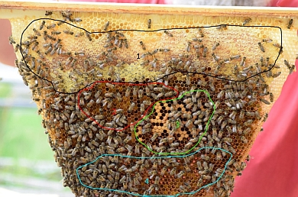A beehive can be divided into different sections. Honey is usually stored in the periphery. The next section is usually used to store pollen, the main nutrition of bee larvae. The inner section of the honeycomb, which is the best protected area, is where the queen lays her eggs, hence called the brood chamber. The cells under the brood chamber are often empty because they are used as temporary storage for nectar and pollen.

Fig. 1: Honey comb with different areas

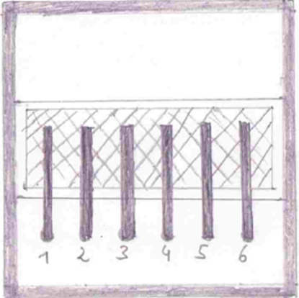The bees have to maintain a constant temperature of 35°C in the hive, so that the larvae can develop into adults.

Fig. 2: Position of the temperature sensors within the eHive (from above; open hive)

## Tasks

1. Different areas are marked in the honeycomb (see fig. 1). Using the text above, name the uses of the different areas.
2. Visit the BeeBIT homepage (www.beebit.de) to research the following measurements:

beehive: DEU-FKG-1  
sensors: temperature 1 to temperature 6  
period: midnight 13/10/2016 to midnight 16/10/2016

beehive: DEU-DHG-1  
sensors: outside temperature  
period: midnight 13/10/2016 to midnight 16/10/2016

1. Describe the diagram.
2. Explain the data.

For the quicker pupils:

1. Examine the changes in the hive (according to the change in temperature) in different eHives during the year.